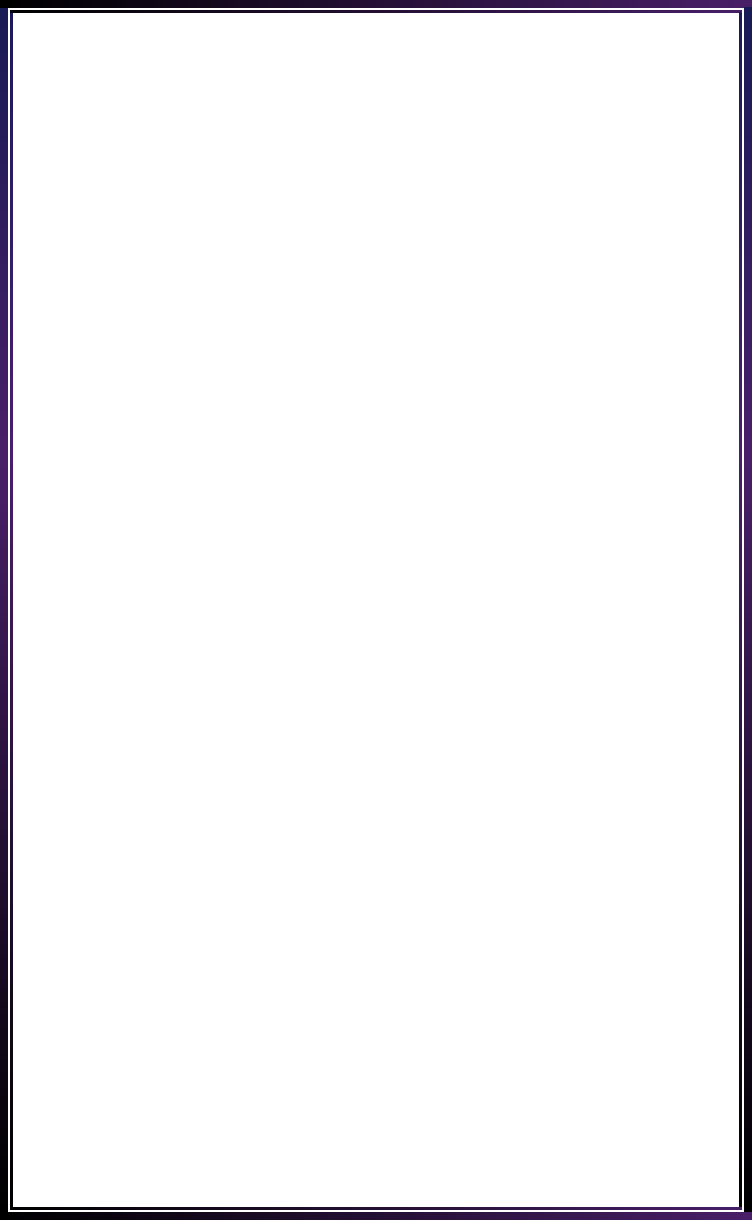

**INNOVATE. CREATE. SOLVE**

Bengaluru, Karnataka, India

AN INTERNSHIP REPORT

ON

“SRI MARUTHI PHARMA”

#### Bachelor of Engineering

#### In

#### Computer Science and Engineering

#### Submitted by: VIDHYASHREE C(1MJ18CS166)

#### VANDHANA M(1MJ18CS160)

#### SUPRAJA S(1MJ18CS149)

#### VARSHINI G(1MJ18CS162)

#### INSERT YOUR COLLEGE LOGO HERE

#### C:\Users\ADMIN\Desktop\MVJ LOGO.png

**An Autonomous institute**

**(Affliated to Visvesvaraya Technological University,Belagavi**

**Approved by AICTE,New Delhi,**

**Recognized by UGC under 2(f) & 12(B)**

**Accredited by NBA and NACC MVJ COLLEGE OF ENGINEERING**

**2021**

## ABOUT THE COMPANY

IC Solution (ICS) is a digital service provider that aims to provide software, designing and marketing solutions to individuals and businesses. At ICS, we believe that service and quality is the key to success

We provide all kinds of technological and designing solutions from Billing Software to Web Designs or any custom demand that you may have. Experience the service like none other!

Some of our services include:

Development - We develop responsive, functional and super-fast websites.

We keep User Experience in mind while creating websites. A website should load quickly and should be accessible even on a small view-port and slow internet connection.

Mobile Application - We offer a wide range of professional Android, iOS& Hybrid app development services for our global clients, from a startup to a large enterprise.

Design - We offer professional Graphic design, Brochure design & Logo design. We are experts in crafting visual content to convey the right message to the customers.

Consultancy - We are here to provide you with expert advice on your design and development requirement.

Videos - We create a polished professional video that impresses your audience.

**TABLE OF CONTENTS**

Tableofcontents i

Overview ofthe Project 1

introduction page 2

content 3

Tools Used 4

Implementation 5

Snapshots 13

Bibliography 17

## OVERVIEW OF THE PROJECT

## Project Name:Website forSri Maruthi Pharma

**Team Members:VIDHYASHREE C**

**VANDHANA M**

**VARSHINI G**

**SUPRAJA S**

## This project is based on Web Development And its Applications. The main objective of this project is to learn the implementation of HTML, CSS and JavaScript. The basic webpage of this project is created using HTML and styling of the webpage is done using CSS.

## This webpage is about Sri Maruthi Pharma

Sri Maruthi Pharma in Bangalore is one of the leading businesses in Surgical Equipment Dealers. Also known for Surgical Equipment Dealers, Pharmaceutical Product Distributors, Medical Equipment Dealers, Pharmaceutical Distributors, Surgical Item Dealers, Medicine Distributors, Medical Product Dealers, Generic Medicine Wholesalers and much more.

1

## INTRODUCTION

## SMP is a company, established under a mission of service to humanity, we provide a wide range of pharmaceuticals and we are building a reputation of quality and integrity known around the world. The products that we supply at SMP Meets the best safety and quality standards. We are being audited regularly by officials to ensure that the highest safety and quality criteria were met.

## 

## 

## 

## CONTENT

SMP or Sri Maruthi Pharma are dealers in:

* + - Chemists
    - Surgical Equipment Dealers
    - Pharmaceutical Product Distributors
    - Medical Equipment Dealers
    - Pharmaceutical Distributors
    - Pharmaceutical Product Manufacturers
    - Medicine Wholesalers Surgical Face Mask Dealers
    - N95 Face Mask Dealers
    - Medicine Distributors
    - Generic Medicine Distributors

# TOOLS USED

### Software Requirements

* Visual Studio Code2019.
* Google Chrome or Microsoft Edge of latestversion.
* Front End: HTML,CSS,JS(optional)
* Linux 7.1 or Windows XP/7/8/10OS or Mac OS

### Hardware Requirements

* Pentium 200-MHz computer with a minimum of 64 MB of RAM (128 MB of RAM recommended).
* Monitor with a refresh rate of at least 40Hz for a smooth GUI experience(optional).

# IMPLEMENTATION

# Source Code(landingpage.html):

<!DOCTYPE html>

<html lang="en">

<head>

    <meta charset="UTF-8">

    <meta http-equiv="X-UA-Compatible" content="IE=edge">

    <meta name="viewport" content="width=device-width, initial-scale=1.0">

    <title>SRI MARUTHI PHARMA CHAMREJPET BANGLORE</title>

    <h1 style="background-color:#FFF8DC";

    link rel="stylesheet" href="https://cdnjs.cloudflare.com/ajax/libs/font-awesome/5.10.2/css/all.min.css">

    <link rel="stylesheet" href=pharm.css>

</head>

<body>

    <header>

        <nav>

            <h1>SRI MARUTHI PHARMA CHAMREJPET</h1>

            <div class="menu">

                <a href="#">HOME</a>

                <a href="contact us 2.html">CONTACT US</a>

                <a href="About us 3.html">ABOUT US</a>

              </div>

        </nav>

        <main>

            <section>

                <div

                    style="text-align:center;">

                    <img src="Bionic Engineers Logo - White.jpg" style="width:600px; height:500px">

               </div>

    </p><h2>Description</h2></p>

                <p>Sri Maruthi Pharma in Chamarajpet, Bangalore is one of the leading businesses in the Pharmaceutical Product Distributors.

            </section>

            <p class="container">

                <div

                    style="text-align:center;">

                    <img src="Background image.jpg" style width="50%">

                </div>

            </p>

        </p>Sri Maruthi Pharma in Bangalore is one of the leading businesses in Surgical

        Equipment Dealers.

        Also known for Surgical Equipment Dealers, Pharmaceutical

        Product Distributors, Medical Equipment Dealers, Pharmaceutical Distributors,

        Surgical Item Dealers, Medicine Distributors, Medical Product Dealers, Generic

        Medicine Wholesalers and much more</p>

        <h3>The Dealers of Sri maruthi pharma are:</h3>

        <ul>

        <li>Chemists</li>

        <li>Surgical Equipment Dealers</li>

        <li>Pharmaceutical Product Distributors</li>

        <li>Medical Equipment Dealers</li>

        <li>Pharmaceutical Distributors</li>

        <li>Pharmaceutical Product Manufacturers</li>

        <li>Medicine Wholesalers</li>

        <li>Surgical Face Mask Dealers</li>

        <li>N95 Face Mask Dealers</li>

        <li>Medicine Distributors</li>

        <li>Generic Medicine Distributors</li>

        <li>Pharmaceutical Product Wholesalers and much more</li>

        </ul>

        </main>

        </header>

        <br>

        <q><i>'The best and most efficient pharmacy is within your own system'</i></q>

        <br>

        <a href="#" class="btnone">TOP</a>

        </body>

        </html>

# Source Code(contact us.html):

<!DOCTYPE html>

<html>

<head>

  <title>CONTACT_US</title>

  <link rel="stylesheet" type="text/css" href="css/contact.css">

  <meta name="viewport" content="width=device-width, initial-scale=1.0">

</head>

  <body style="background-color:palegreen;

  <header>

     <nav>

       <div class="row clearfix">

             <a href="landingpage 1.html">HOME</a>

             <a href="contact us 2.html">CONTACT US</a>

            <a href="About us 3.html">ABOUT US</a>

         <a href="#" class="mobile-icon"  onclick="slideshow()"> <i class="fa fa-bars"></i></a>

       </div>

     </nav>

      <div class="main-content-header">

        <div class="container">

  <div style="text-align:center">

    <h2>Contact Us</h2>

    <br>

    <p>contact us for better health:</p>

    <br>

  </div>

  <div style="text-align:center;">

    <img src="front image.png" style="width:75% height:50%">

  </div>

  <div class="row">

    <div class="column">

      <h1> WE CARE</h1>

      <br><b>we deliver the best care</b>.a better way to shop for health and beauty</p>

          <h1>...AND HOME-DELIVER TOO.</h1>

          <br><p>Don't feel like stepping out but want medicines at home? Call us at<p style="font-family: body;color: #bf55ec">

011-24655641/42</p>and we'll be there at your doorstop with your order!</p>

<p>Email:-information@srimaruthipharma.co.in</p>

    </div>

    <div class="column">

      <form action="/action_page.php">

        <label for="fname">First Name</label>

        <input type="text" id="fname" name="firstname" placeholder="Your name..">

        <label for="lname">Last Name</label>

        <input type="text" id="lname" name="lastname" placeholder="Your last name..">

        <label for="phone number">Phone number</label>

        <input type="text" id="ph no" name="phonenumber" placeholder="Your phone number..">

        <label for="email id">Email id</label>

        <input type="text" id="email id" name="emailid" placeholder="Your emai id..">

        </select>

        <label for="subject">Subject</label>

        <textarea id="subject" name="subject" placeholder="Write something.." style="height:170px"></textarea>

        <input type="submit" value="Submit">

      </form>

    </div>

  </div>

</div>

<footer>

  <a href="https://www.facebook.com/" class="fa fa-facebook"></a>

<a href="https://twitter.com/login?lang=en" class="fa fa-twitter"></a>

<a href="https://www.instagram.com/accounts/login/?hl=en" class="fa fa-instagram"></a>

<a href="https://accounts.snapchat.com/accounts/login?continue=https%3A%2F%2Faccounts.snapchat.com%2Faccounts%2Fwelcome" class="fa fa-snapchat-ghost"></a>

<a href="https://accounts.google.com/signin/v2/identifier?flowName=GlifWebSignIn&flowEntry=ServiceLogin" class="fa fa-google"></a>

</footer>

</header>

<script type="text/javascript">

   function slideshow(){

      var x = document.getElementById('check-class');

      if(x.style.display === "none"){

        x.style.display="block";

      } else{

        x.style.display="none";

      }

   }

   mybutton = document.getElementById("myBtn");

// When the user scrolls down 20px from the top of the document, show the button

window.onscroll = function() {scrollFunction()};

function scrollFunction() {

  if (document.body.scrollTop > 20 || document.documentElement.scrollTop > 20) {

    mybutton.style.display = "block";

  } else {

    mybutton.style.display = "none";

  }

}

// When the user clicks on the button, scroll to the top of the document

function topFunction() {

  document.body.scrollTop = 0; // For Safari

  document.documentElement.scrollTop = 0; // For Chrome, Firefox, IE and Opera

}

 </script>

 </body>

</html>

# Source Code(about us.html):

<!DOCTYPE html>

<html>

</div>

</nav>

     <h style="font-family: Impact, Haettenschweiler, 'Arial Narrow Bold', sans-serif">ABOUT US</h>

  <div class="main-content-header">

   <hr>

   <div style="text-align:center;">

    <img src="pharmacy shop.jpg" style="width: 30% height=30%">

  </div>

   <p style="font-family:Georgia, 'Times New Roman', Times, serif; color: blue;">

    <br> SMP is a company, established under a mission of service to humanity, we provide a

     wide range of pharmaceuticals and we are building a reputation of quality and integrity known

     around the world.

     The products that we supply at SMP Meets the best safety and quality standards. We are being

     audited regularly by officials to ensure that the highest safety and quality criteria were met.</p>

 <div class="container">

<div class="content">

</div>

</html>

# Source Code(pharm.css):

@import url('https://fonts.googleapis.com/css?family=Times new roman&display=swap');

* {

    box-sizing: border-box;

}

body {

    background-color: #ff1ef4;

    color: #02100D;

    display: flex;

    font-family: "Times new roman", sans-serif;;

    flex-direction: column;

    align-items: center;

    justify-content: center;

    padding: 10px;

    min-height: 100vh;

}

div{

    margin: 10px 0 20px;

    text-align: justify;

}

p {

    margin: 5px 0;

}

h2 {

    margin: 10px 0 20px;

    text-align: center;

}

body .btnone{

    background: #fff;

    color: #000;

    position: fixed;

    bottom: 20px;

    right: 30px;

    padding: 15px;

    border-radius: 10px;

    font-size: 18px;

}

.btnone:hover{

    background: #0ca0f5;

    color: white;

}

}

# IMPLEMENTATION

# Snapshots :

# 

# 

# 

# Contact us page:

# 

# About us page:

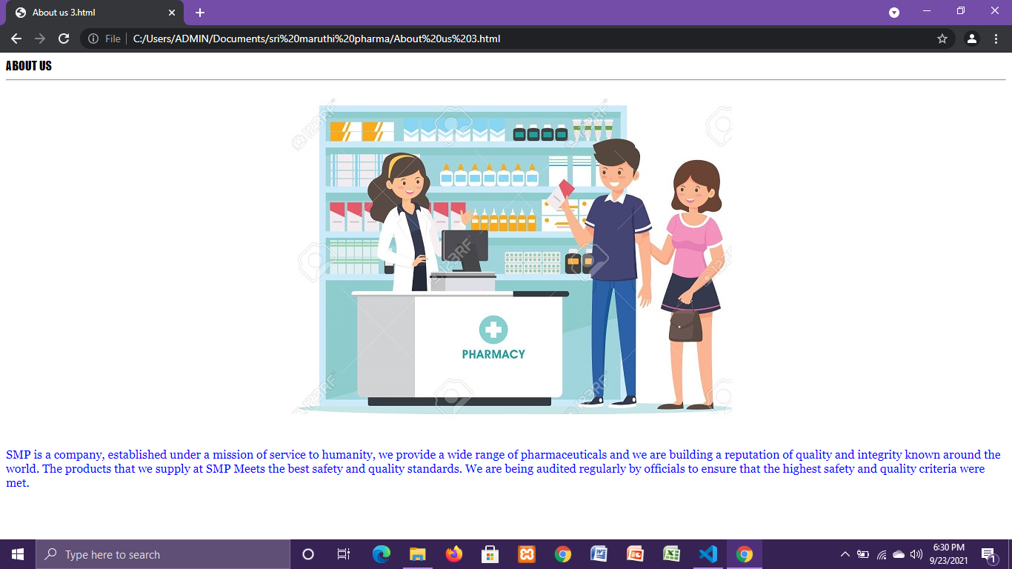

**BIBLIOGRAPHY**

* https://[www.w3schools.com](http://www.w3schools.com/)
* https://[www.geeksforgeeks.org](http://www.geeksforgeeks.org/)
* <https://freefrontend.com>

## About my TEAM

## su-va-va-vi

## VIDHYASHREE C(1MJ18C166): designed contact us page and implemented js in it.

## VANDHANA M(1MJ18CS160):implemented the landing page and about us page with html ad css.

## SUPRAJA S(1MJ18CS149):gave ideas for designing pages and did report.

## VARSHINI G(1MJ18CS162) :gave ideas for designing about page.

## All of us did this project whole heartedly,and indulged ourselves with all interst and efforts to create something new.

## We used to join google meet and were show casing to others what we did .like tis all of us shared common ideas and finally came up with this project.

## THANK YOU